Exercise-7_ Financial Forecasting

Algorithm
- Input the current amount, growth rate, and number of years.
- If years = 0, return the current amount.
- Otherwise:
  - Increase the amount by the growth rate.
  - Recursively calculate the value for the remaining years.
- Display the forecasted amount.

FinancialForecast class

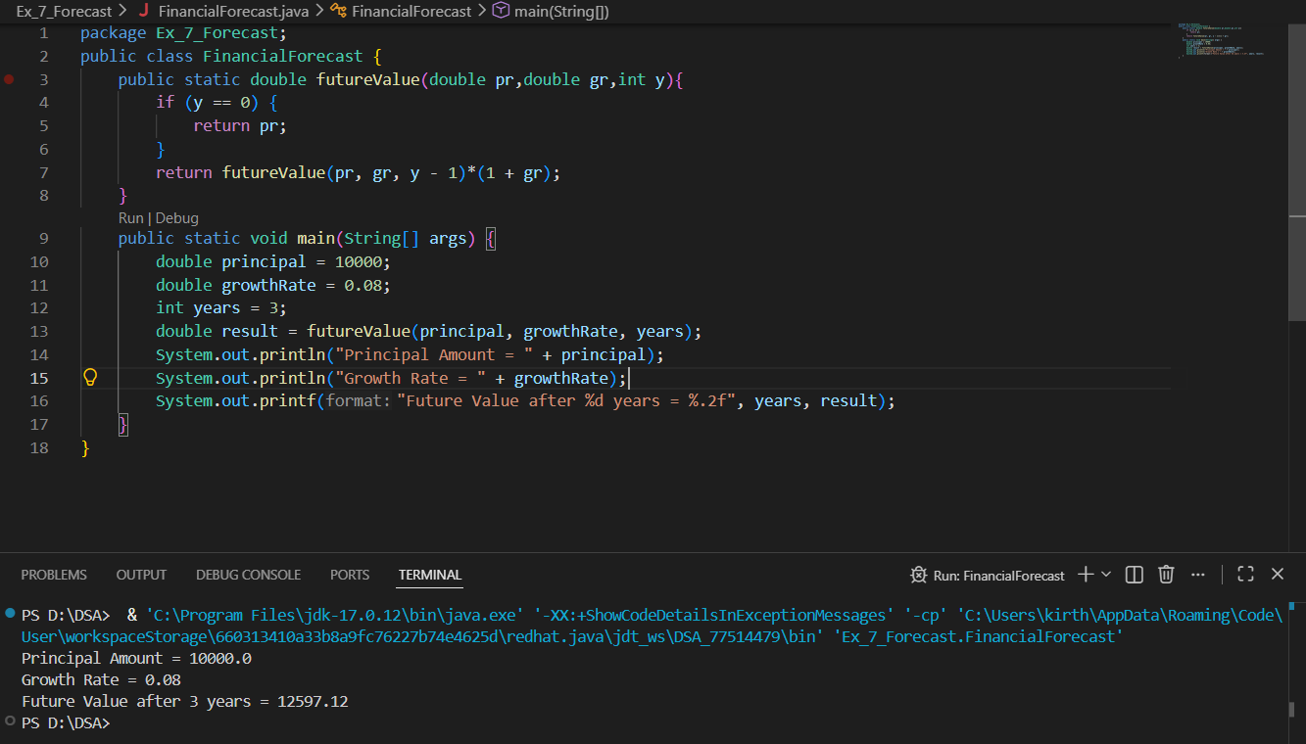

Output:


Analysis
Aspect | Result
Time Complexity | O(n)
Space Complexity | O(n)
Limitation | More recursive calls for large n
Optimization | Memoization / Fast Exponentiation
Optimized Complexity | O(log n)
Conclusion | Fast Exponentiation is more efficient for large forecasts.

